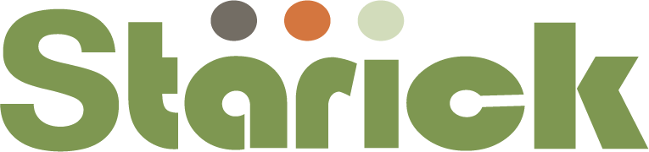
RESOURCE LINKS
Service resources
child-safe-organisations-wa-guidelines-updated-november-2019.pdf (ccyp.wa.gov.au)
https://childsafety.pmc.gov.au/what-we-do/national-principles-child-safe-organisations
https://childsafe.humanrights.gov.au/learning-hub/organisational-self-assessment
https://childsafe.humanrights.gov.au/learning-hub/e-learning-modules
Keeping our kids safe - SNAICC
Watch and Learn - Australian Childhood Foundation Professionals
Resource 1A: Self-audit tool Child Safe Standards (word) - DHHS Service Providers (dffh.vic.gov.au)
Home - Child Wise
Youth Participation Kit: Organisations (communities.wa.gov.au)

Culture and diversity
https://ccyp.vic.gov.au/assets/resources/tipsheet-safety-children-cult-ling-diverse.pdf
https://ccyp.vic.gov.au/assets/resources/tipsheet-cultural-safety-aboriginal-children.pdf
https://ccyp.vic.gov.au/assets/resources/tipsheet-safety-children-disability.pdf
Being_Culturally_Safe_PDF_4MB.pdf (adobe.com)
Child Safe Standards (nds.org.au)

Children and Young People Resources
Always Be You - Be You
Convention on the Rights of the Child: Educational Resource - Bing video
Are you a child or young person with something to say? - Child Wise
What are children's rights? - YouTube

Parents
child-safe-organisations-wa-parent-resource-updated-november-2019.pdf (ccyp.wa.gov.au)
tipsheet-childsafe-org-5922.pdf (ccyp.vic.gov.au)

Online Learning
Watch and Learn - Australian Childhood Foundation Professionals
Right of a Child _poster-childfriendly.pdf

