PARENT CONSENT FORM
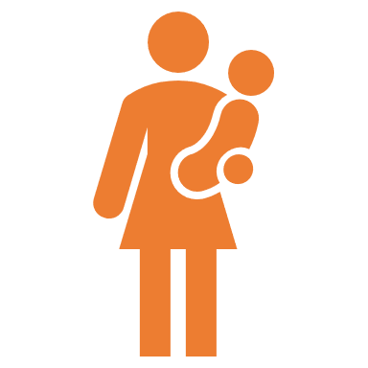
Children and Young People's Engagement Project
COVID-19 Resource Kit
Would you like to help us create support resources for families living in refuges and outreach services? We are working on developing a COVID-19 Resource Kit
You will be asked some questions.
Sharing your experiences and telling us what has been useful in the past, will help us to create better resources for families in the future.
With your permission your children will also be asked about what would be helpful for them in a kit. They will also be asked for ideas about designing the kit and how it can be made child friendly.
Your involvement in the project is voluntary, and your information will remain confidential. You may withdraw your participation at any time.
WHAT ABOUT PRIVACY?
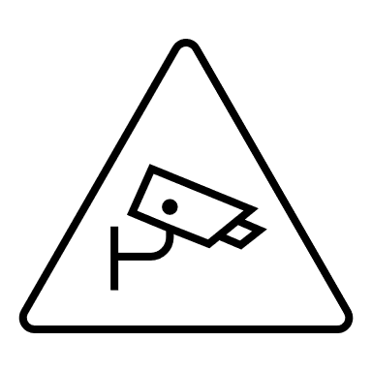
You will not be identified in anything that arises from the consultation. All information you provide will be stored securely and will remain confidential.
I HAVE QUESTIONS…. WHO CAN I SPEAK TO?
Please talk to your Child Advocate or Women's Advocate if you have any questions. The resources are being developed by …………(name). You can contact them at ……….. (email address)
I have read the participant information and consent to participate in this consultation. (Please circle)
Yes
No
I have read the participant information and consent to my children participating in this consultation. (Please circle)
Yes
No

Signed (client)…………………………………………………………………………………… Date…………/…………/2021

Signed (staff)…………………………………………………………………………………… Date…………/…………/2021

