TIP SHEET

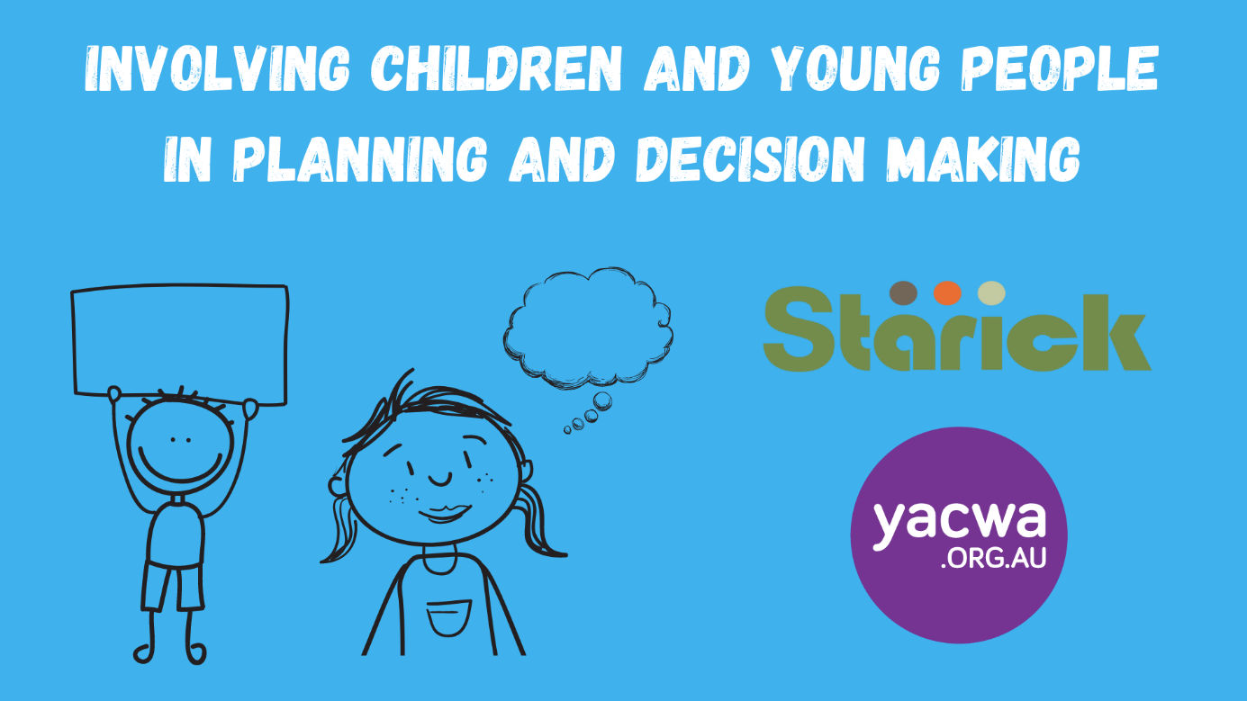

The aim of this tip sheet is to give you a quick reference guide to involving children and young people that engage with your service in planning and decision making.
This tip sheet complements training delivered in 2021 by the Youth Affairs Council of WA on this topic.

The foundations
Before you start involving children and young people in plans and decisions, you first need to make sure you have a solid foundation. Ask yourself the following questions?
☐ | Is this a genuine consultation? Will the children and young people I’m going to talk to have an opportunity to influence the plan or decision in some way?
☐ | Do I have the time and capacity to adequately plan the consultation from beginning to end?
☐ | Do I have the resources that I need to deliver the consultation safely and ethically with the children and young people I want to talk with?
If the answer to these questions is yes! Then proceed to planning your consultation. If the answer is no to one or more, or you are unsure, then that may mean that it’s not the right time or project to consult with children and young people on. Or it could mean that you need to scale back your plans or gather more support for the work you want to do.

Planning the consultation
Consultations can be big or small. They can be one off, with one group of children or young people, or you can integrate a point of consultation into your service, that overtime, captures a range of opinions and ideas.
When you are starting out, you should ask yourself some key questions (outlined below). Thinking about and documenting your answers will help you pick the activities that you want to run. The considerations outlined below apply to all types of consultation.
Use the boxes below to write the answers and it will form the start of your consultation plan.
What type of information do I want to gather?
If you want information on planning school holiday activities that will require a different method of consultation to planning a play space or getting input into policy. You should think about how what depth you want or need in the information you are gathering.
Do I want to gather information from just one group of children and young people at a single point in time, or a range of children and young people over a longer period of time?
If you want information over a long period of time, you may want to integrate something into your service that all children can contribute to, such as voting jars or photo board.
How old are the children and young people I want to speak with?
Some activities, such as polls or surveys can easily be used for all ages (with small adaptations), other activities are best suited to younger or older age groups
How can I maximise access and inclusion for all children and young people?
There are things you should consider in order to build good access and inclusion practice. For example using activities that involve minimal literacy or using images where children and young people from all cultures and demographics see themselves represented.
What could go wrong?
Thinking in advance about what could go wrong, will help you plan. Have backup activities and be prepared for some children and young people to not want to participate.
What resources do I need?
Planning in advance what you need to make or create to get this consultation working will maximise success. Resources includes staffing, physical resources, space/venue and reimbursements or incentives.
What mechanisms do I need to put in place to make sure the consultation is as safe as possible for children and young people?
This will include planning appropriate staff, an appropriate venue, informed consent (both children/young people and parents), being clear about young where information will go and how children and young people can opt out of participation.

Consultation activities
Once you have started to plan your consultation, you can move on to thinking about activities. Below is a list of activities talked about in the training. There are hundreds more—the internet is your friend. It will also be helpful for you to talk between services about what has worked and what hasn’t.
Activity | Brief description | Suitable for
The way the wind blows | Statements are read out and participants move from one side of the room to the other if they agree/disagree with OR like/dislike the statement. You can put ticks and crosses or happy and sad faces on either end of the room. Remind participants not to just follow their friends. | All ages  No literacy  Avoid for sensitive topics
The best and the worst | Participants draw or write (or both) about their best version of something and their worst, i.e. best/worst neighbourhood, youth centre, outdoor space, support staff or anything else you can think of. | All ages  Minimal literacy (scribe or talk to for intent)
Picture collage | Create range of pictures on a topic and ask participants to pick one (or more) based on what you want to know, i.e. something that represents as time you felt safe, or happy, or a place you like to go in your neighbourhood. | All ages (but more suited to younger children)  No literacy (but scribe the discussions)  Capturing ideas over time or at a single point in time
Monster collage | Ask participants to draw a happy monster and a sad/worried monster (or another character). Then explore why that monster is happy and sad—for example where the monster is, who it is with or what it is doing, This activity can help participants explore difficult issues whilst not making it personal. | Children  Participants with some literacy, but can also be done with an adult scribe  Exploring more difficult topics
Creating a map | Ask participants to create a map on large paper or whiteboard. It could be of places they use in community, and how their get there, who they go to for support, or where they feel safe. You can them talk with participants about the map. | Individuals and groups  All ages  Minimal literacy
Props for questions | Add questions about a topic to a wheel and spin it, asking them the question it lands on. Or you could use a chatterbox, or dice. You can give out small prizes or sweets for participation. | Individuals and groups  Minimal literacy (read out and scribe answers)  Avoid for sensitive topics
Activity | Brief description | Suitable for
Role play | Ask participants to pretend they are the person in charge of making decisions. It could be the CEO, the Mayor, the Boss—whatever works best or is most meaningful for your service or the participants. They then get to say what they would do in that role. Props can be fun, such as a hat, medal or a wand. When wearing the prop, that participant gets to speak. | All ages  No literacy (scribe responses)
Lego models | A big box of Lego is set out and participants are invited to create a model based on a question or theme such as ‘if you could create your perfect outdoor space what would it look like?’ The value of this lies in the conversation that the group or the individual has while creating it. You can also use clay or plasticine. | Individuals and groups  All ages  No literacy required (scribe significant points)
Polls and voting | If there is one topic you want to get a range of opinions on either with a group or over time, polling is a good option. You could set up voting jars with fun counters, a board with voting options, or an online option. | All ages  Minimal literacy required (pictures can be used)
Participatory budgeting | Use Monopoly or play money to encourage participants to make decisions about what they would prioritise if they were in charge. This helps understand where children and young people’s interests lie and also fosters an understanding of finite resources and decision making within limits. | Individuals and groups  All ages  Basic numeracy understanding ideal (but can be supported)
Surveys | Surveys can be used in print copy or online for a variety of topics. With children and young people, you should use simple language only ask questions you are actually going to use the data of, not just because you think you should ask that question. Only ask age, sex, identity, school, suburb etc if you are going to use that for analysis. | Individuals and groups  Moderate literacy required
Journey mapping | Journey mapping can be done with an individual participant and their story, but it’s preferable to ask participants to create a ‘persona’ or a typical young person and then map their points through a situation or service. This activity can help see where things ‘went wrong’ or where there could have been opportunities to make a difference. | Young people  Individuals or groups (with a persona)  If looking at service journey, this should be done with trauma informed staff

Check-box guide to planning
Before you deliver your consultation, make sure you can tick off the following:
☐ | I have considered the access and inclusion needs of the children and young people and planned accordingly.
☐ | I have considered the cultural needs of the children and young people and planned accordingly.
☐ | I have considered the safety of the children and young people including:  - Using questions/activities that minimise the chance of disclosures  - Using scenarios to de-personalise situations  - Putting strategies in place to manage disclosures if they occur  - Having adequate staffing in place (especially for children with additional needs)  - Using a venue, or space in the service where the children and young people feel comfortable
☐ | I have developed parent/guardian consent procedures and gained the consent of the children and young people’s guardian for them to participate (this could be verbal in small, informal consultation situations).
☐ | I have developed a consent procedure for the children and young people and sought their consent; this includes:  - Adequate, age appropriate explanation of the consultation activities  - Adequate, age appropriate explanation for why you are gathering this information, what it will be used for and who will see it, including managing expectations  - Checked for understanding  - Explained that children and young people should only participate if they want to  - Explained the children and young people can change their mind at any time
☐ | I have considered how the information that children and young people shared with me will be kept confidential and how confidentiality will be explained to them.
☐ | I have put strategies in place to ensure I will understand the intent and detail of what children and young people are telling me; this is especially important if the activity involves drawing or pictures. It may involve scribing or writing down what children and young people tell you in their own words.
☐ | I have planned an age appropriate evaluation mechanism to check if young people enjoyed the consultation, felt their opinions were heard and to find out how we could improve in the future.
☐ | I have made a plan to thank or reimburse the children and young people for their contributions. Depending on the age of the children and young people, and the time, type or depth of consultation, this may include certificates, food, toys, gift vouchers, a prize draw or financial reimbursement. You could use stamp card that they use over a range of activities and get a prize at the end.
☐ | I have considered how I will follow up with children and young people to tell them about what happened with their information, how that has impacted a decision. This is called, ‘closing the feedback loop.’

